مناقصة شراء مستلزمات تطويــر المصادرالمشعة و معمل الكيمياء بمصنع الوقــــــــــــود
مجمع مفاعـــل مصر البحـثي الثاني لعـــام 2026/2025

أولا: مستلزمات تطويــر المصادرالمشعة
Company | Required Quantity | Items | No
NEST | 2PC | Syringe Filter:  Pore size: 0.22µm & Diameter 25mm & Sterile & Non-pyrogenic & Membrane Material:PES Company NEST(50PC) | 1
USA  Or  UK | 30 box | Air Filter  Syringe filter: Chrom Tech® PTFE (hydrophobic), Diameter 13mm pore size 0.22µm membrane solution PTFE Material USA (box 100PC) | 2
Korea | 5 pc | Sterile single use Insulin Syringes 10 micro-milli (medical, 200 pieces/ box) Korea | 3
Korea | 2 pc | Sterile single use Syringes 50 micro-milli (medical, 200 pieces/ box) Korea | 4
------- | 50 pc | Sterile single use Syringes 500 micro-milli Syringe 50ml (medical application) | 5
GMS company | 100 pc | جهاز وريد (جهاز حقن المحاليل الوريدية-استخدام طبي) (GMS company) | 6
------- | 20 Kg | Low density polyethylene Plastic bags flat (40 cm X 60 cm, 30 micron thickness) transparentشفاف | 7
-------- | 10 Kg | Low density polyethylene Plastic bags flat (100 cm X 150 cm , 30 micron thickness ) transparentشفاف | 8
غذائي كوري | 7 | PVC stretch Film size X-Large (40cm) 4.5 kgغذائي مستورد | 9
------- | 7 Kg | مسمار سن بنطه راس عريضه،طوله 16 مم  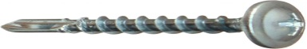 | 10
------- | 1000 | Plastic pipette dropper 5 ml | 11
------ | 15 | Aluminum Foil Roll, for Packing Food 40 cm width (Roll 1 Kg) | 12
Germany | 500  PC | Glass Tube Column with two edges 10m length X 10 mm diameter with glass disc(G2) | 13
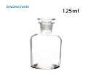 | 80 pc | Lab Glass Reagent Bottle Narrow Mouth with Glass Stopper, Reusable, 125 ml | 14
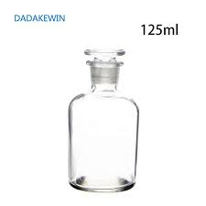 | 50 pc | Lab Glass Reagent Bottle Narrow Mouth with Glass Stopper, Reusable, 250 ml | 15
هندي | 1000  PC | Glass Tube Column with two edges 7.5cm length X 0.6 mm diameter with glass disc(G2) | 16
Medical Use | 80,000  pc | Aluminum Caps 20mm with for penicillin vial (diameter : 20.3 mm X height:7.3 mm) Medical Use  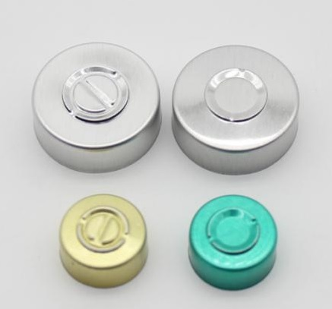 | 17
Company | Required Quantity | Items | No
Medical Use | 30,000  pc | Aluminum Caps 13mm with for penicillin vial (diameter :13.3 mm X height 6.3 mm ) Medical Use. | 18
Pharma grade | 90000  pc | 20 mm Rubber stopper : Pharma grade with RFS bags (20-A) Cleaned, Washed, and WFI water Rinsed, Depyrogenated and terminally sterilized  (Top Di : 20 mm X Top Height: 3 mm X Plug Di 13 mm X Overall height : 9 mm) جاهز لعملية التعقييم في الأتوكلاف بدون أي غسيل او معالجة  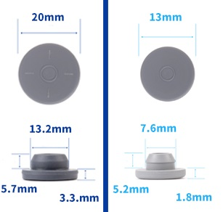 | 19
Pharma grade | 30000  pc | 13 mm Rubber stopper : Pharma grade with RFS bags (13-A) Cleaned, Washed, and WFI water Rinsed, Depyrogenated and terminally sterilized  (Top Di : 13 mm X Top Height:2 mm X Plug Di :8 mm X Overall height :7 mm). جاهز لعملية التعقييم | 20
USA | 3 pc | Parafilim roll :Roll of Parafilm M Laboratory Film in card board dispenser. Item number: PM996 Roll size: 4 inches x 125 feet (10 cm width X 38 meter) - Made in USA | 21
----- | 60 pc | Glass Funnel, Heavy Wall Lab OD=7 cm | 22
----- | 20 pc | Lab Poly propylene Funnel, Heavy Wall OD=7 cm X 14 cm Lenght | 23
(BMS Dental company- Italy) | 1 Packet | Steam sterilization integrator (BMS Dental company) | 24
------- | 4 pc | Lab Store Box metallic, electrostatic coating, two doors, several shelves, 2 meter X 90 cm X 45 cm | 25
----- | 200 | Disposable Protective Coverall Chemical Suit | 26
هندي | 1000  PC | Glass Tube Column with two edges 7.5cm length X 0.6 mm diameter | 27
Germany | 100 PC | Stainless steel filter  Filter body SS 316 L, OD= 73.03 mm, ID=63 mm, height = 78 mm (with lid),  Filter upper edge (OD= 97 mm, ID=63 mm, height = 3 mm )  The lid has OD= 97 mm, ID=63 mm, height = 20 mm  The filter Filtering material: SS 316 L, thickness 7 mm, pore size 10 μm, SIPERM R-10 | 28
USA/  Europian/Japan / Koria | 1 pc | Heating Circulator with open bath, (9 to 13 Liter)  Working temperature range : (°C) +20 ... +150  Pump capacity flow rate (l/min) : 15  Pump capacity flow pressure (psi): 5.08  Filling volume liters: 9 L .. to 13Liter  Dimensions W x L x H (inch): 15 x 15.8 x 16.6  Bath tank : Stainless steel | 29
Company | Required Quantity | Items | No
USA/  Europian/Japan / Koria | 2 pc | Stuart A4000 - Aquatron Water Still, 4 l/hr, Double Distilled, 240V  Model: A4000D  Output, l/hr: 4, double  Pyrogen content*: Pyrogen content | 30
Azlone  U.K. | 20 Pc | Wheaton® 250 ml Media Bottles, Borosilicate Glass, PTFE Caps | 31
Malaysia | 50 | X-large hand latex Powder Free (100 pairs per each packet) | 32
Simax | 5 pc | Conical flask 3000 ml | 33
Simax | 15 pc | Conical flask 250 ml | 34
Simax | 15 pc | Conical flask 100 ml | 35
Simax | 15 pc | Conical flask 50 ml | 36
Simax | 15 pc | Conical flask 25 ml | 37
Simax | 20 pc | Glass Beakers, Borosilicate glass 10 ml | 38
Simax | 10 pc | Glass Beakers, Borosilicate glass 25 ml | 39
Simax | 20 pc | Glass Beakers, Borosilicate glass 50 ml | 40
Simax | 30 pc | Glass Beakers, Borosilicate glass 100 ml | 41
Simax | 50 pc | Glass Beakers, Borosilicate glass 250 ml | 42
Simax | 20 pc | Glass Beakers, Borosilicate glass 500 ml | 43
Simax | 20 pc | Glass Beakers, Borosilicate glass 1000 ml | 44
Simax | 15 pc | Glass Beakers, Borosilicate glass 2000 ml | 45
Simax | 15 pc | Glass cylinder 500ml | 46
Simax | 15 pc | Glass cylinder 250ml | 47
Simax | 15 pc | Glass cylinder 100 ml | 48
Simax | 30 pc | Glass cylinder 10 ml | 49
Simax | 40 pc | Glass cylinder 25 ml | 50
Simax | 30 pc | Glass cylinder 50 ml | 51
Simax | 20 pc | Volumetric flask glass 10 ml, with stopper, borosilicate glass, class A | 52
Simax | 15 PC | Volumetric flask glass 50 ml, with stopper  borosilicate glass, class A | 53
Simax | 15 PC | Volumetric flask glass 100 ml, with stopper,  borosilicate glass, class A | 54
Simax | 10 PC | Volumetric flask glass 250 ml, with stopper,  borosilicate glass, class A | 55
Simax | 5 PC | Conical flask glass 3000 ml, with stopper | 56
---- | 20 pc | Micro-Tec Teflon Beaker PTFE, 100ml, high purity, heat resistance for 300 C, non-porous PTFE with a smooth finish and a flat base | 57
----- | 20 pc | Tall form graduated Beaker glass 1000 ml, Borosilicate,heat resistance for 1000 C | 58
Company | Required Quantity | Items | No
----- | 2 pc | Micro pipette 20-100 µl, Germany | 59
----- | 10 pc | Micro pipette 100-1000 µl, Germany | 60
----- | 5 pc | Micro pipette 1000-5000 µl, Germany | 61
----- | 3 pc | blue tips 1ml , package 500 pcs | 62
----- | 3 pc | white tips 5ml, package 500 pcs | 63
----- | 5 pc | Washing bottle 500 ml | 64
----- | 5 pc | Spatula (double end for mg ) stainless-steel | 65
----- | 4 pair | Quartz cell for UV spectroscopy, Germany | 66
----- | 50 piece | Separating Funnel With Glass Stopcock 100ml, 250ml. (25 pcs*250ml, 25 pcs*100ml) | 67
----- | 5 | dissolver glass tube (Gas absorption tube)100ml with inner and outer gas filter, Borosilicate, high purity, heat resistance for 1000 C  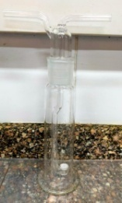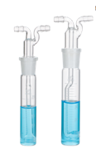 | 68
----- | 10 pc | Filter Paper whatman, qualitative 1 (10*12.5 cm), England | 69
----- | 5 box | pH-whatman (indicator papers) from 0-14, England | 70
----- | 3 pc | Graduated Centrifuge Tube With Conical Bottom 500 Pcs of 15ml, 50ml and 100 ml | 71
----- | 5 box | Snap cap vials, clear plastic container and transport with 10 ml size, (500 Pcs)  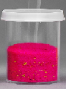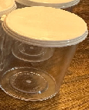 | 72
Germany | 20 plates | Filter plate R 20 : 220 x 280 X 5 mm  Filter plate R 20: 220 x 280X 5 mm: High Porous sintered stainless filter Plate Siperm R20(Stainless Steel AISI 316 L).Pore size 20 microns. Company Tridelta Siperm GmbH, Germany | 73
china | 100 | Glass tube 15 cm ball joint at bottom, G2 sintered filter and glass funnel 5 cm diamter at the top | 74
Company | Required Quantity | Items | No
----- | 1 Pc | 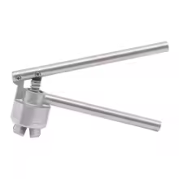  Manual Vial Crimper for Perfume or Glass Bottles 20 mm | 75
------- | 1 PC | Manual Vial Crimper for Perfume or Glass Bottles 13 mm | 76
----- | 20 PC | Straight burette stopcock with PTFE plug محبس سحاحة مستقيمة مع (سدادة/حنفية/) من التيفلون  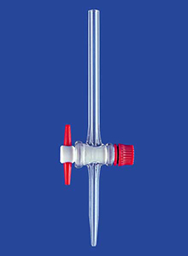 | 77
شركة  إياكو | 56100  Vail | فايــل أبيض 8R قطر 22 مم X 45 مم مقبض 20 مـم  {المصرية الدولية للأمبولات (إياكو)} (الكرتونة 255 فايل ) | 78
شركة  إياكو | 92400  Vail | فايل أبيض 17/15 قطر24مم X 58 مم مقبض 20 مـم  {المصرية الدولية للأمبولات (إياكو)} (الكرتونة 210 فايل ) | 79
شركة  إياكو | 2000  Vail | فايل أبيض قطر30 مم X 55 مم مقبض 20 مـم  {المصرية الدولية للأمبولات (إياكو)} | 80
Germany | 25 | Quartz pipe with two edges (14mmX 2.5 mm), 10 cm length, 7 inner diameter, 11 mm external diameter and G3 sintered disc (Packet 100 PC) | 81
الإجمــــــــالــــــــــى

ثانيا : الأدوات المطلوبة للإنتاج والمعامـــــــــل بمصنــــــــع الوقـــــــــود النووي
No. | Items | Required Quantity
82 | Ceramic Hotplate magnetic stirrer, LED digital display, with plate size 20*20 , with microcrystalline ceramic plate, 500C– USA, Japan, Korea, Germany,European Union | 3
83 | Multiposition ceramic hotplate stirrer 175x175mm, with microcrystalline ceramic plate, LED digital display, with 3 positions, 500 C, with each plate size 20*20 – USA, Japan, Korea, Germany,European Union. | 1
84 | BENCHTOP HIGH SPEED CENTRIFUGES  - Max Speed (rpm): 6000-10000 rpm.  -TX-400 swing-out rotor: This rotor is designed for a broad range of  laboratory throughput needs. With a max capacity of 8×100ml, or 16×50 ml, or 4×250 ml, with its vials  -Temperature Setting (℃) : -10～+40, Timer: 1-99 min, USA, Japan, Korea, Germany,European Union | 1
85 | Professional Multi-Parameter  pH-ORP-ISE-mV-Temperature, Benchtop Meters, Three types of logging modes (for pH, ISE and mV) with RS232/USB interface & GLP, USA, Japan, Korea, Germany,European Union | 1
86 | Ph meter benchtop, parameters (pH, ions, redox, temp.), Range (-2 to +20), accuracy(±0.002 pH), Temp. range(-5 to +105), voltage range (-2000 to +2000 mv), Resolution ( 0.01) pH, , USA, Japan, Korea, Germany,European Union | 1
87 | Double junction reference electrode (Ag/Cl Ag) and platinum electrode(Dm140)( Meteler Toldo Dl – 53) with 25ml of inert sol. | 1
88 | Ion selective F electrode with bnc connected to coleparmer or Meteler Toldo, with 25ml of inert sol, | 1
89 | pH electrode glass, refillable electrodes, with bnc connection, with 25ml of inert sol, Germany | 3
90 | UV-Vis Spectrophotometer  Must be supplied with 4 Quartz cell  - Double-beam UV-Vis spectrophotometer.  - Wavelength range: 190 to 1100 nm.  - Wavelength accuracy: ± 0.05 nm at D2 peak 656.1 nm, ± 0.3 nm for entire range.  - Stray light: Less than 0.004%.  - Photometric range: Absorbance: -4 to 4 Abs, Transmittance: 0% to 400%.  - Multi display mode: (Spectrum, Photometric, Quantitation and Kinetics mode).  - Power requirements: AC100, 120,220,230,240 V, 50/60 Hz, 140 VA.  It must be from USA/Japan/ Germany | 1
الشروط الفنية
- عند فحص العروض المقدمة الأولوية للبضاعة الحاضرة مع الإلتزام بالمواصفات الفنية المطلوبة .
- بصفة عامة تكون الأولوية في الاختيار لمنتجات الأمريكية والالمانية ويابانية المنشأ ثم المنتجات الأوربية الأخري.
- يجب ذكر بلد المنشاء لكل صنف سوف تتقدم به الشركة في العرض بجانب إسم المنتج.
- تلتزم الشركات بتقديم كتالوج/ دليل المواصفات الفنية(data sheet) للأصناف الواردة بالعرض المقدم منها خصوصا تلك النود: 1&2&24&28&29&30&59&60&61&82&83&84&85&86&87&89&90 .
- تلتزم الشركات بإحضارعينة مع العرض المقدم منها للبنود: 13&16&&27&20&19&18&1768.
- البنود الواردة بالمناقصة قابلة لتجزئة .
- يجب أن تكون الأصناف الموردة غير منتهية الصلاحية
- مدة التوريد 3-4 أشهر من تاريخ قبول العطاء ،ما عدي البنود أرقام &29&30& 73&82 &83 & 84 & 85 & 86 &87 & 88 & 89&90& مدة التوريد 4-6 شهر .

